# Agenda of the MOBIUS FOLIO and OpenRS Enhancements Committee

Wednesday, May 14, 2025 at 11:00 am

Online, via Zoom (see below for how to connect)

1. Call to order

a. Planned Absences: Samantha Perkins

b. Planned Guests: N/A.

2. Adoption of the agenda

3. April 23, 2025 meeting minutes discussion and vote:

a. Meeting minutes not yet available

b. Should all meeting minutes be added to the bottom of this page - <https://mobiusconsortium.org/node/2165>?

4. Updates

a. Stephanie Marvin and Stephanie Ruhe resigned from Committee

5. Existing Business

a. Committee Members’ Subject Expertise:

i. <https://docs.google.com/document/d/1TekgCGJfYmSYWb5LoAk7-G4f1rfqKWhxUTyJsevXe6A/edit?usp=sharing>

ii. Should this document be used to assign members to Subcommittees for the purpose of reviewing and prioritizing current and future Enhancement requests? (Stephanie)

b. Outstanding Enhancements Document:

i. <https://docs.google.com/spreadsheets/d/1Goz-DYplINVnWd6vKs-GQk1dG2-zNwWv98KP20blIV4/edit?gid=0#gid=0>

ii. Stephanie and Andrew’s subject area assignments to outstanding enhancement requests:

1.  [https://docs.google.com/spreadsheets/d/1LjjS5ibTz5Kaw8dE2mlPKnOKKnYZfKkU/edit?usp=sharing&ouid=100396398036292149766&rtpof=true&sd=true](https://docs.google.com/spreadsheets/d/11b2jIh9oTNQyQheXTm4ZmhOsNAKEOPRv/edit?pli=1&gid=430070568#gid=430070568)

c. Google form for inputting new enhancement requests – any updates?

i. <https://docs.google.com/forms/d/e/1FAIpQLSe5QvlKZGtn3SJB8BIw-YNJNe5O-TocF8t2PhQUcDUYLluMBA/viewform?usp=mail_form_link>

6. New Business

a. Discussion and vote on abandoning Roberts Rules for all future meetings (Stephanie)

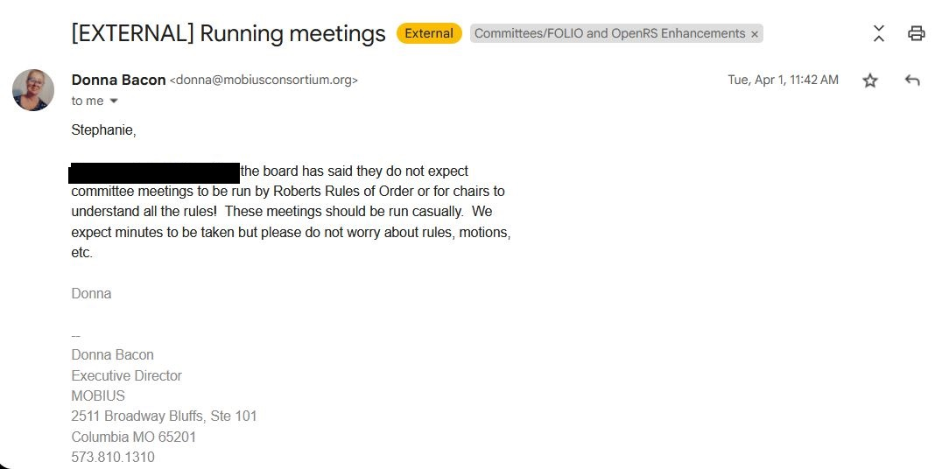

b. Request for a Google folder to store all Google documents for this Committee together (agendas, meeting minutes, enhancement request form, subject experts list, etc.) to which all members have access and can add documents. (Stephanie)

c. Watch Jira introductory video from Adrienne’s email on May 9, 2025.

7. Adjourn Meeting

**FOLIO & OpenRS Enhancement Committee**

**Stephanie Spratt, 2025-2027, Chair**  
Assistant Director for Technical Services, Missouri Western State University

**Andrew Stout, 2025-2028, Vice-Chair**  
Access Services Librarian, University of Missouri-St. Louis

**Kim Kietzman, Board Representative**Director, Altoona Public Library

**Samantha Perkins, Board Representative**Library Director, Missouri Valley College

**Kirsten Abotsi, 2025-2028**  
Lead Librarian, Library Systems, St. Louis Community College

**Frances Behrman, 2025-2027**  
Access Services Librarian, Kenrick-Glennon Seminary

**Rebecca Brown-Gregory, 2025-2028**  
Technical Services Librarian, St. Louis Art Museum

**Stephanie Chinn, 2025-2028**  
Systems Librarian, Saint Louis University

**Donna Church, 2025-2028**  
E-Resources Librarian, Missouri Baptist University

**Jacob Dudley, 2025-2027**  
Head of Access Services, Northwest Missouri State University

**Seth Huber, 2025-2028**  
Technical Services Librarian/Head of Cataloging, University of Missouri - Columbia

**Cameron Nuss, 2025-2028**  
Research & Instruction Librarian, William Woods University

**Jennifer Parsons, 2025-2028**  
Assistant Director & Access Services Librarian, Central Methodist University

**Catherine Price, 2025-2027**  
Content Services Librarian, Rockhurst University

**Kathleen Rahman, 2025-2027**  
Systems Librarian, University of Missouri - Columbia

**Rachel Utrecht, 2025-2027**  
Technical Services Librarian, William Woods University

**Vivian Gould, MOBIUS Organizer**  
Systems Librarian, MOBIUS

**Steve Strohl, MOBIUS Organizer**  
Associate Director, Member Services, MOBIUS

**Donna Bacon, Ex-Officio**  
Executive Director, MOBIUS

Topic: Enhancements Committee Meeting

Time: May 14, 2025 11:00 AM Central Time (US and Canada)

Every 2 weeks on Wed, 79 occurrence(s)

Please download and import the following iCalendar (.ics) files to your calendar system.

Weekly: https://us02web.zoom.us/meeting/tZMvcuusrT0oEtbMgEYI4DFZ-pk_rcItwxW1/ics?icsToken=DLEFQoZY95HBhGL8nwAALAAAAHqwDNgSKAIJq6zH8JB_nYpkAiPGKouIB3J_F0alLsR8EtCcAAx400tNygK9aKC5o_ab6AbOI0Bu5DKkbDAwMDAwMQ&meetingMasterEventId=4c-xNkdET4yL5ztt9ixBTw

Join Zoom Meeting

https://us02web.zoom.us/j/87252436282?pwd=Z27NWf42CwuyLWwKAQaezbEax5gSku.1

Meeting ID: 872 5243 6282

Passcode: mobius

---

One tap mobile

+13092053325,,87252436282#,,,,*810631# US

+13126266799,,87252436282#,,,,*810631# US (Chicago)

---

Dial by your location

• +1 309 205 3325 US

• +1 312 626 6799 US (Chicago)

• +1 646 931 3860 US

• +1 929 205 6099 US (New York)

• +1 301 715 8592 US (Washington DC)

• +1 305 224 1968 US

• +1 253 205 0468 US

• +1 253 215 8782 US (Tacoma)

• +1 346 248 7799 US (Houston)

• +1 360 209 5623 US

• +1 386 347 5053 US

• +1 507 473 4847 US

• +1 564 217 2000 US

• +1 669 444 9171 US

• +1 669 900 6833 US (San Jose)

• +1 689 278 1000 US

• +1 719 359 4580 US

Meeting ID: 872 5243 6282

Passcode: 810631

Find your local number: https://us02web.zoom.us/u/kbFBF8tTBd