# Minutes of the MOBIUS FOLIO and OpenRS Enhancements Committee

Wednesday, March 26, 2025 at 11:00 am

Online, via Zoom (see below for how to connect)

1. Call to order for the new committee and introductions.
   1. Planned Absences: *Kirsten Abotsi.*
   2. Planned Guests: N/A.
   3. Absences: *Stephanie Marvin, Jennifer Parsons*
2. Adoption of the agenda

***Andrew Stout made the motion to adopt the Agenda and Donna Church seconded the motion, without objections.***

1. **March 7, 2025** meeting minutes discussion and vote<https://docs.google.com/document/d/1ZboXEFDERBgvifwLYc0qY8LqVEwOXZHQKaN0nHQlkXA/edit?tab=t.0>

***Review of minutes from March 7th. Not hearing any objections or corrections, Stephanie Spratt called for the adoption of the minutes. Andrew Stout moved / Stephanie Ruhe seconded. Without objection.***

1. Existing Business
2. Discussion of the committee charge incorporating discussion points from listserv

***Stephanie Spratt asked for the committee to look through the enhancement requests and get familiar with them as well as looking at JIRA and being familiar with how that works. Folks were encouraged to look at the official SIGs (Special Interest Groups) and consider joining one or more of them. A flow chart on the official process was created (see attached, below). Discussion on walking through the diagrams or bullet points (step-by-step). Discussion on enhancement requests and reviewing them on their merits and prioritizing them. Do we need the entire committee or subcommittee to review and approve to move forward? Much discussion ensued on how the work of the committee should be reviewed by the membership.***

1. ***Do we want to formalize a process?***
2. ***Or should we address the backlog?***
   1. ***No one commented on the backlog; Stephanie Spratt moved to table discussion on the committee charge as there are other items to get to here.***
3. Vote on meeting frequency and schedule

***Second and Fourth Wednesday of the month was agreed to via email. Stephanie Spratt called for the motion; Donna Church made the motion, seconded by Andrew Stout. Passed without objection.***

1. New Business
2. FOLIO User acceptance testing (UAT) opportunities - should this Committee commit to participate? (Stephanie S.)

***Is this committee interested in taking part in User Acceptance Testing (UAT)? Testing those things we’ve officially asked for is our priority. This is part of continuing business going forward on how things go through our committee.***

1. April meeting plans - continue without Stephanie S., or hold email discussions in lieu of meetings? (Stephanie S.)

***How do people feel about this since we’re early on in the process? As long as the Vice Chair is available, we should be fine (Andrew Stout). This is for April 9th and 23rd. As long as Andrew can run the meeting, we’ll have recordings and Stephanie Spratt will catch-up.***

1. Discussion of utilizing Google Form (form to spreadsheet) to automatically keep track of incoming enhancement requests instead of using Request Tracker and manually keeping a separate document updated.

***This was brought up by the MOBIUS office - while there might be a bit of privacy at issue, this should be OK unless folks have objections. MOBIUS can use CAPTCHA to add a level of security to the document that MOBIUS will manage and be responsible for maintaining.***

1. Adjourn Meeting

***Stephanie Spratt called for a motion to adjourn. That motion was made by Andrew Stout at 12:02 pm, seconded by Donna Church. No objections.***

**FOLIO & OpenRS Enhancement Committee**

**Stephanie Spratt, 2025-2027, Chair**  
Assistant Director for Technical Services, Missouri Western State University

**Andrew Stout, 2025-2028, Vice-Chair**  
Access Services Librarian, University of Missouri-St. Louis

**Kim Kietzman, Board Representative**Director, Altoona Public Library

**Samantha Perkins, Board Representative**Library Director, Missouri Valley College

**Kirsten Abotsi, 2025-2028**  
Lead Librarian, Library Systems, St. Louis Community College

**Frances Behrman, 2025-2027**  
Access Services Librarian, Kenrick-Glennon Seminary

**Rebecca Brown-Gregory, 2025-2028**  
Technical Services Librarian, St. Louis Art Museum

**Stephanie Chinn, 2025-2028**  
Systems Librarian, Saint Louis University

**Donna Church, 2025-2028**  
E-Resources Librarian, Missouri Baptist University

**Jacob Dudley, 2025-2027**  
Head of Access Services, Northwest Missouri State University

**Seth Huber, 2025-2028**  
Technical Services Librarian/Head of Cataloging, University of Missouri - Columbia

**Stephanie Marvin, 2025-2027**  
Customer Service Supervisor, Davenport Public Library

**Cameron Nuss, 2025-2028**  
Research & Instruction Librarian, William Woods University

**Jennifer Parsons, 2025-2028**  
Assistant Director & Access Services Librarian, Central Methodist University

**Catherine Price, 2025-2027**  
Content Services Librarian, Rockhurst University

**Stephanie Ruhe, 2025-2027**  
ILS Administrator, Springfield-Greene County Library District

**Kathleen Rahman, 2025-2027**  
Systems Librarian, University of Missouri - Columbia

**Rachel Utrecht, 2025-2027**  
Technical Services Librarian, William Woods University

**Vivian Gould, MOBIUS Organizer**  
Systems Librarian, MOBIUS

**Steve Strohl, MOBIUS Organizer**  
Associate Director, Member Services, MOBIUS

**Donna Bacon, Ex-Officio**  
Executive Director, MOBIUS

Enhancements Committee Meeting

Time: Mar 26, 2025 12:00 PM Central Time (US and Canada)

Every 2 weeks on Wed, 79 occurrence(s)

**Meeting ID: 872 5243 6282**

**Passcode: mobius**

---

One tap mobile

+13092053325,,87252436282#,,,,*810631# US

+13126266799,,87252436282#,,,,*810631# US (Chicago)

---

Dial by your location

• +1 309 205 3325 US

• +1 312 626 6799 US (Chicago)

• +1 646 931 3860 US

• +1 929 205 6099 US (New York)

• +1 301 715 8592 US (Washington DC)

• +1 305 224 1968 US

• +1 253 205 0468 US

• +1 253 215 8782 US (Tacoma)

• +1 346 248 7799 US (Houston)

• +1 360 209 5623 US

• +1 386 347 5053 US

• +1 507 473 4847 US

• +1 564 217 2000 US

• +1 669 444 9171 US

• +1 669 900 6833 US (San Jose)

• +1 689 278 1000 US

• +1 719 359 4580 US

Meeting ID: 872 5243 6282

Passcode: 810631

Find your local number: https://us02web.zoom.us/u/kbFBF8tTBd

**Process diagram to solicit, manage, settle on, submit, and test enhancements (draft by Stephanie S.)**

Stage 1: Soliciting requests from membership through selecting enhancement requests to send to developer partners (bullets 1-2)

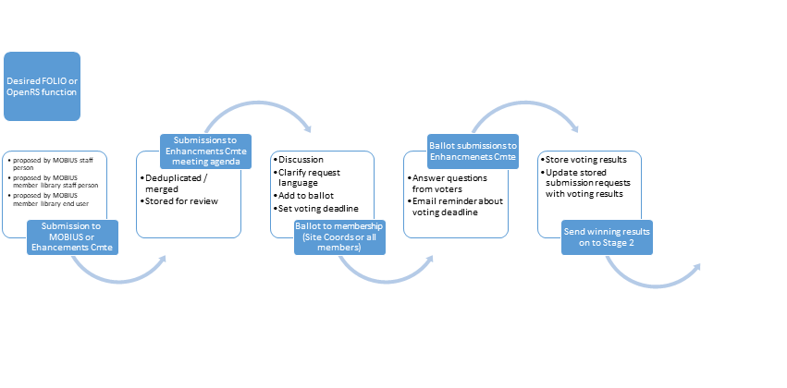

Stage 2: Submitting enhancement requests to developers through communication of functionality addition to system (bullets 3-5)

