October 22, 2015; 10:00 am - Noon
MOBIUS HQ, Columbia MO

CIRC-Courier Committee

Introductions:
Name | Email | Institution
Lisa Farrell | lisa.farrell@eastcentral.edu | East Central College
Steve Strohl | steve@mobiusconsortium.org | MOBIUS
Joshua Lambert | JLambert@MissouriState.edu | MSU
Lori Nash | lnash@stchas.edu | St. Charles
Federico Martinez Garcia | martinezgarciaf@missouri.edu | UM- Columbia
Leisa Walter | LWalter@atsu.edu | A.T. Still
John Mooney | johnm@ccld.us | Camden Co.
Donna Bacon | donna@mobiusconsortium.org | MOBIUS
Charge: Working in conjunction with the MOBIUS staff, this committee will provide input into the circulation and interlibrary loan functions of the MOBIUS Union Catalog. This can include policies, functionality, and other areas related to the courier system and its ability to move physical materials effectively among MOBIUS Member and partner institutions.

Needed:

We will also need someone to serve as Committee Secretary. This person would be responsible for taking minutes at each meeting.

Circulation:

- A/V Materials:
  - Who is lending A/V materials? <see below>
  - Is this something to look further into expanding?
  - Or are there tweaks that need to be made?

NOTE:
https://docs.google.com/spreadsheets/d/1lwh5RA7z28J9sEEJGIGuR-AcobRs72Yc449ZgYSc_kk/edit#gid=0

- 4 Week Check Out:
  - Clusters going to 4 week check out to match MOBIUS 4 week check out.
NOTE:
This is optional; not required at the cluster level. BRIDGES and SWAN changed on their own; LANCE has talked about it, Archway is doing this via MOBIUS.

- Bookbands.
  - Current use and utility--can there be one general purpose bookband?.
  - Is the sticker option like Tulsa still too expensive?
  - If we continue using bookbands cycling older ones out of use.

NOTE:
Label Solution Costs - A basic outline.

Consider an example library. Assumptions:
* 1 workstation for generating pull lists / batch holds
* 1 circulation workstation that will need to print slips when items are checked in and captured for holds.
* Total holds per year: 20,000
* 50% pull list driven
* 50% check-in driven

Costs:
* Print Wizard software: $600
* ~$300/workstation
* Print Wizard custom programming: $12,600
* This is based on a need for 3 print possibilities: An 8 per page layout (8-up), a 1-up roll label layout, and a layout for InnReach holds (this may or may not be needed)
* 1-Up Sticky Receipt Printer: $325
* Supplies: $380
* $0.023/label for 8-up sheet x 10,000 = $230
* $0.015/label for 1-up rolls x 10,000 = $150

Total Year One (setup) Cost: $13,905
Annual (ongoing) Costs: $380

It's *definitely* worth noting that the programming costs (the lion's share) would, assuming we could reach a consortium wide agreement on formatting/content, be a once-per-consortium cost. Assuming 100% adoption and an even split of the costs among the 71 current members (72, but I'm excluding Tulsa), that would be $177.50/member.

To go really big here, if we looked at a bulk buy of programming, 400 one up sticky receipt printers, 400 print wizard licenses, supplies for 750,000 holds with a 60/40 split of pull list vs checkin driven hold slips, including some bulk discounts, we're looking at ~$210,000 year one and $15,000 annual ongoing. Obviously this doesn't lend itself to an even-split formula, but that would look like $3,000/member for year 1, $211/member after that.

- MOBIUS Lost Materials:
  - We had a procedure under 1st Choice, it’s time to look at formalizing one under STAT
  - How are claims going under STAT, are they being filled in a timely manner.
  - What about books lost before STAT took over?

NOTE:
*https://docs.google.com/spreadsheets/d/1vYUioKpc-tMZTS0h-YFKqdmc9-Hv43zWImvIdXkTUZI/edit#gid=1951478235

*Many materials continue to show up just when you think all hope is lost.
*Please direct lost materials to the MOBIUS office.
*E-mail to courier@mobiusconsortium.org will open up a ticket.
*We will work with you to resolve outstanding issues.
*ALA Guidelines; borrowing library pays, but we want to track the process.
*MO-MO materials via STAT only is easy.

Courier:

- Courier Labels:
  - How are things working for others?
  - Are there still more changes coming?
  - Adding in print names or replacing print names with STAT codes.

NOTE:
*Sample labels not yet implemented.
*Labels are for moving materials and what is convenient to the courier(s).
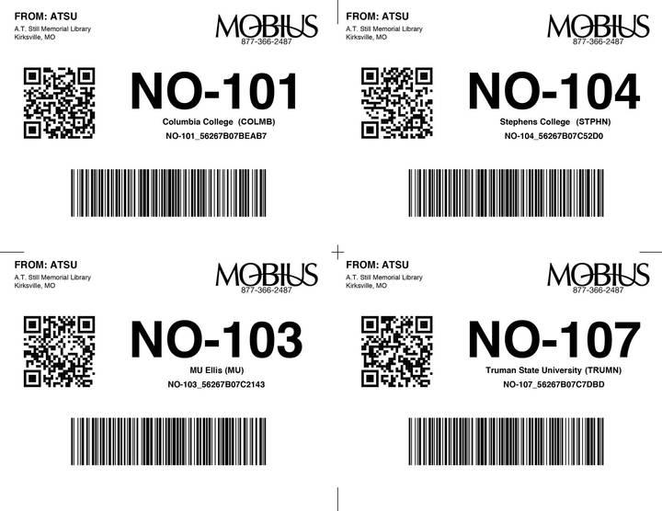
*Potential new out-of-state label – note how different it is from the in-state label.

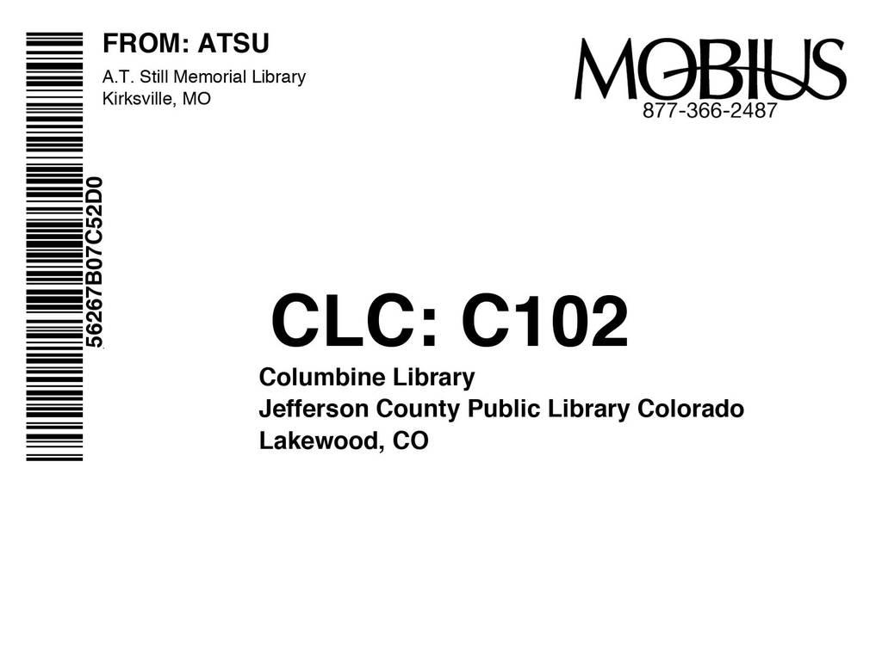

- Courier Bags

NOTE:
*Significant number of bags have come back recently from Colorado.
* Over 500 bags have already come in.
* 600 bags coming this week.
* Another 2,800 to arrive next week, there will be 4,000 in total.
*PS – these new bags and new bags we may order in the future do not and will not have an external / “1st Choice” barcode on them. Barcodes will go on labels.

- MALA:
  - How is it working from MOBIUS HQ end and from libraries using STAT only?
  - Tubs and bags and such

- STAT Update:
  - Driver issues
  - Delivery issues
  - Route issues
  - Courier subcontractors – providing service as needed?
  - Datatrac
  - Reports
  - Courier Map
  - Iowa
  - Tulsa / Springdale exchange

Next meeting: Using Uberconference (or the like). How does December or January sound?

